Literature searching with the Cochrane Library

Exercises

Case:
Timon is 10 years old and obese. His doctor wants to prescribe an intervention to stabilize his weight. However, she is not sure which type of intervention is better, one with the child alone (without the parents) or one with the parents alone (without the child).
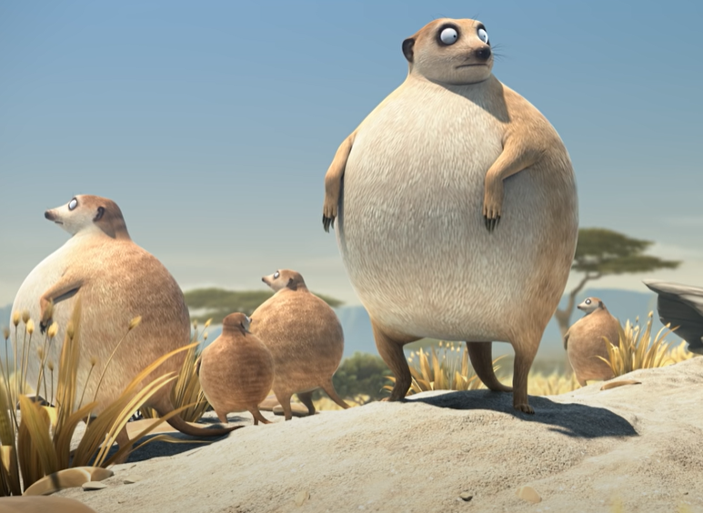
https://youtu.be/57jEMZ87ND8

Exercise 1: What are the PICO concepts of this case and what is the PICO question?
Population:
Intervention:
Control:
Outcome:
PICO Question:

Exercise 2: Find appropriate text words for each PICO aspect. Use Boolean and proximity operators to connect the text words within a PICO aspect. Also use truncation.
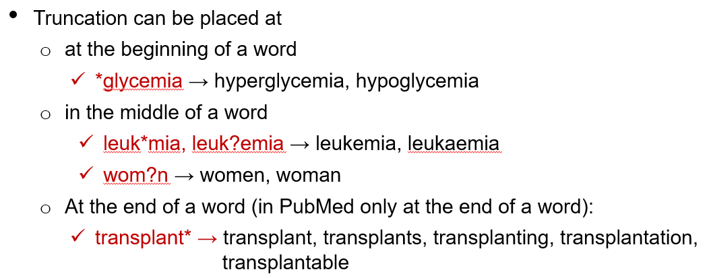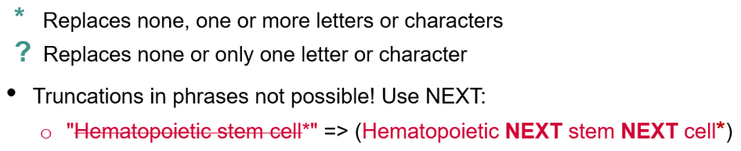
Population
Intervention
Control
Outcome

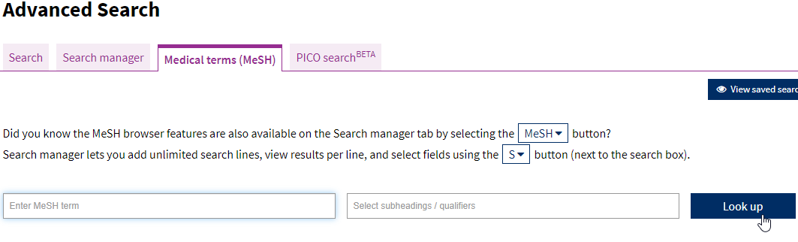
Exercise 3: Find MeSH terms matching the PICO aspects (via Medical terms or search manager) and search for them (add to search manager):

Population
Intervention
Control
Outcome

Exercise 4: Now combine the MeSH search with the text word search. Use the Search Manager for this. Individual lines can be combined with # and the line number.
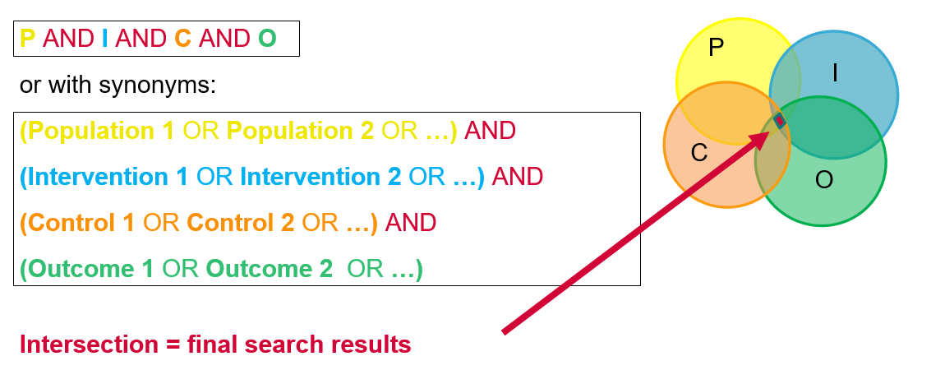

CT

